**Assignment – 1. Create RDS maria DB**

1. Create a DB
2. Copy endpoint

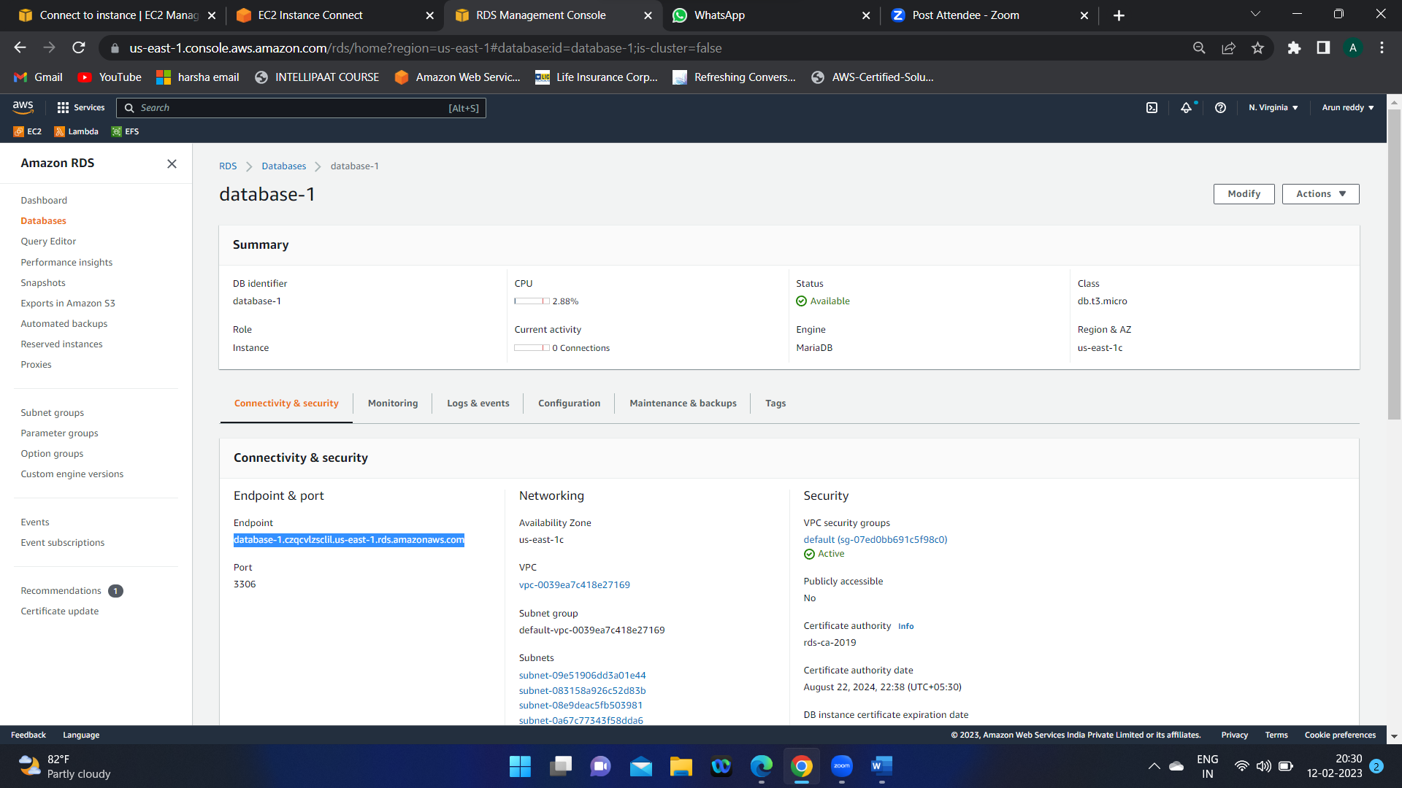

1. Connect the RDB to an EC2 instance

**mysql -h <database-1.cb7cg3oipfv4.ap-south-1.rds.amazonaws.com> -u <admin> -p<password>**

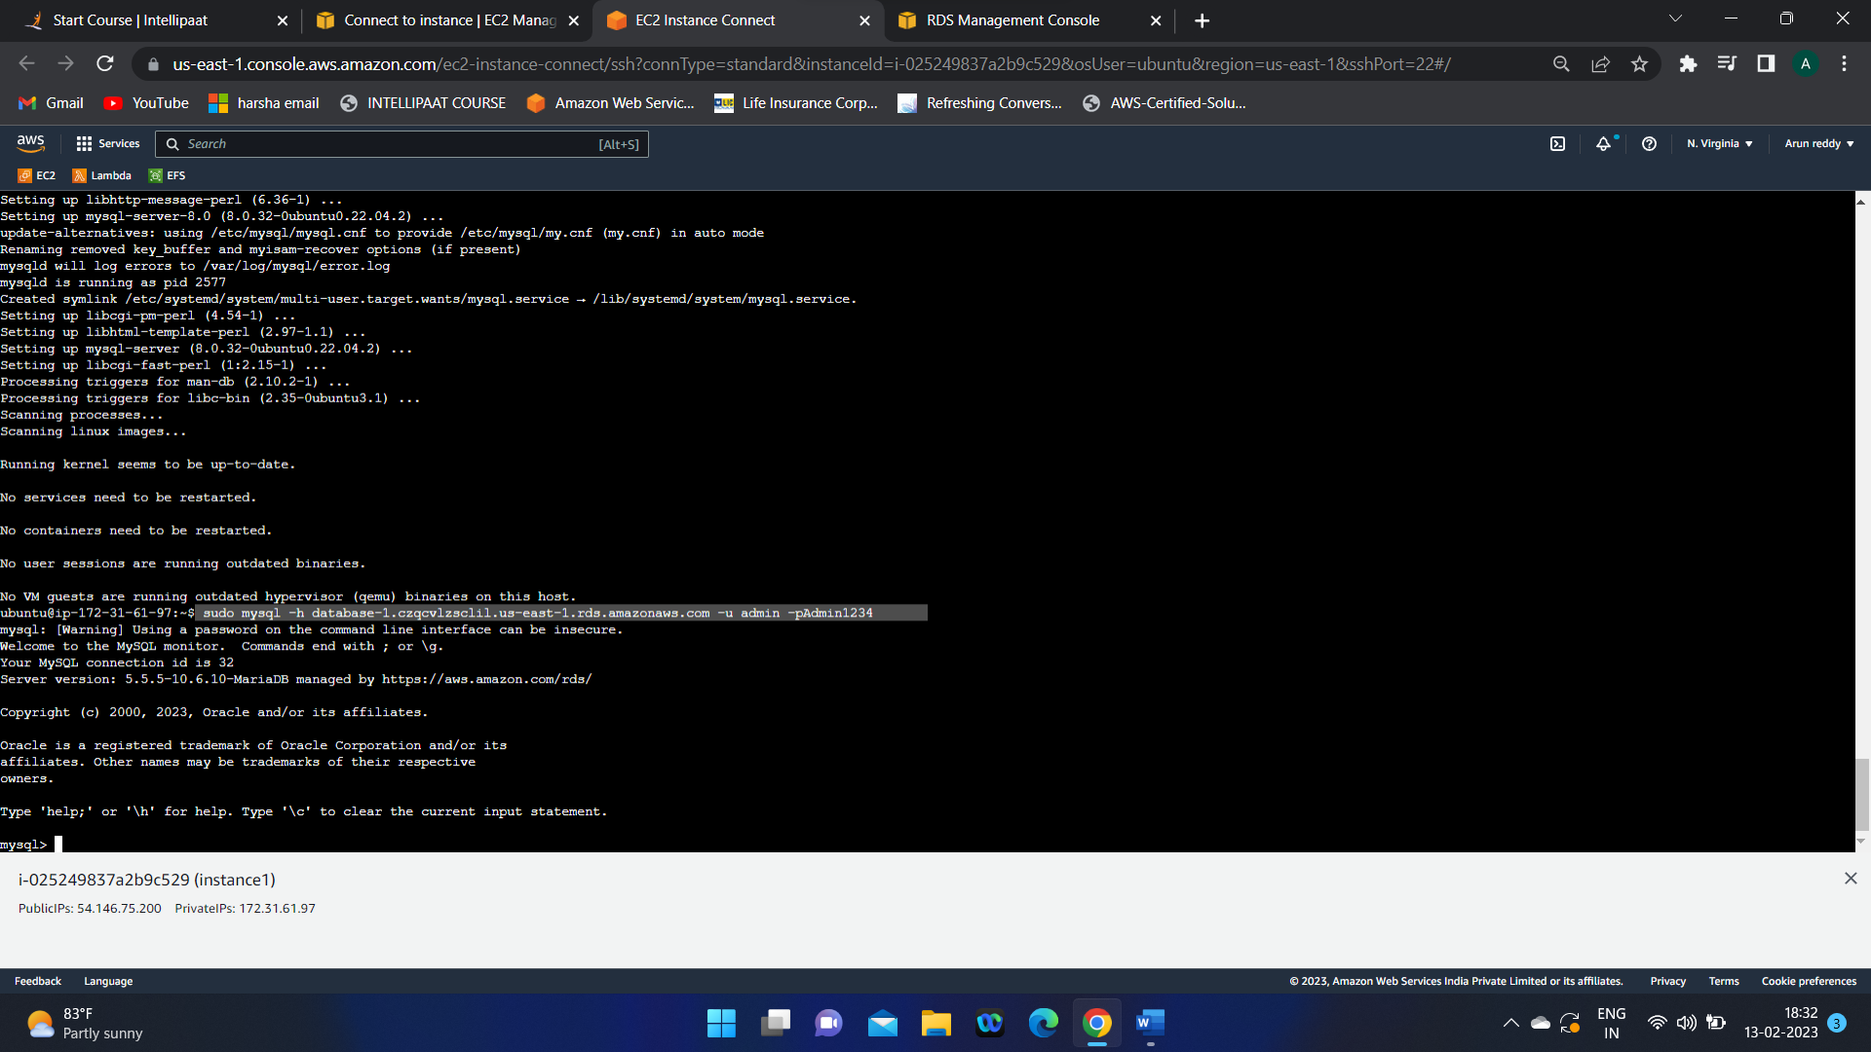

1. Use the Database which we created

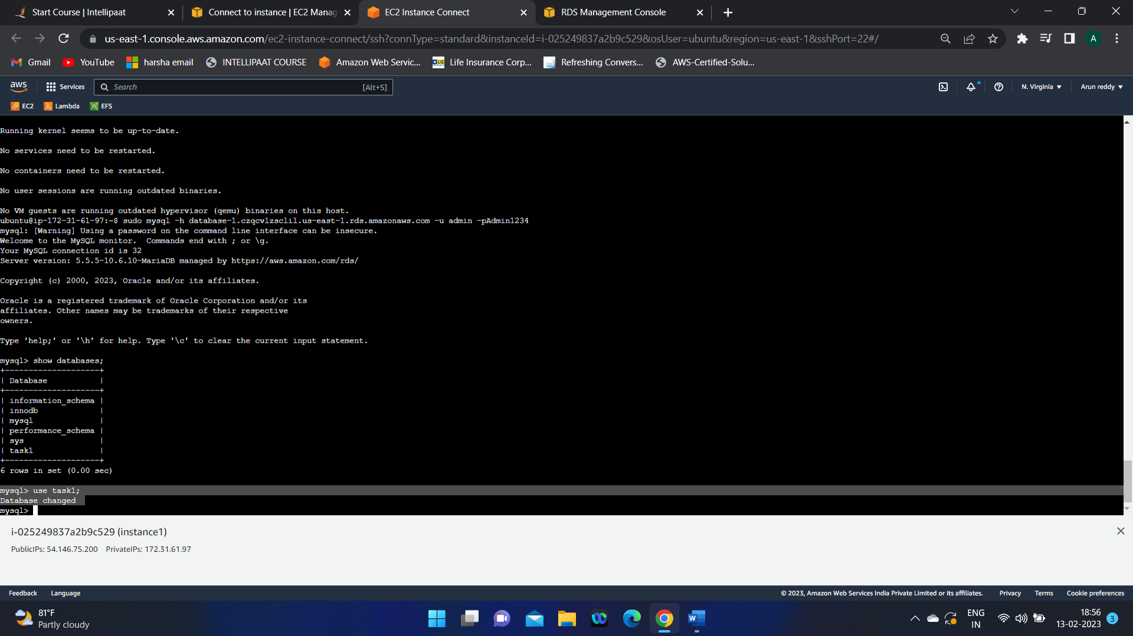

5.Create a table in the database

6.descrbe the table to see the contents in it:

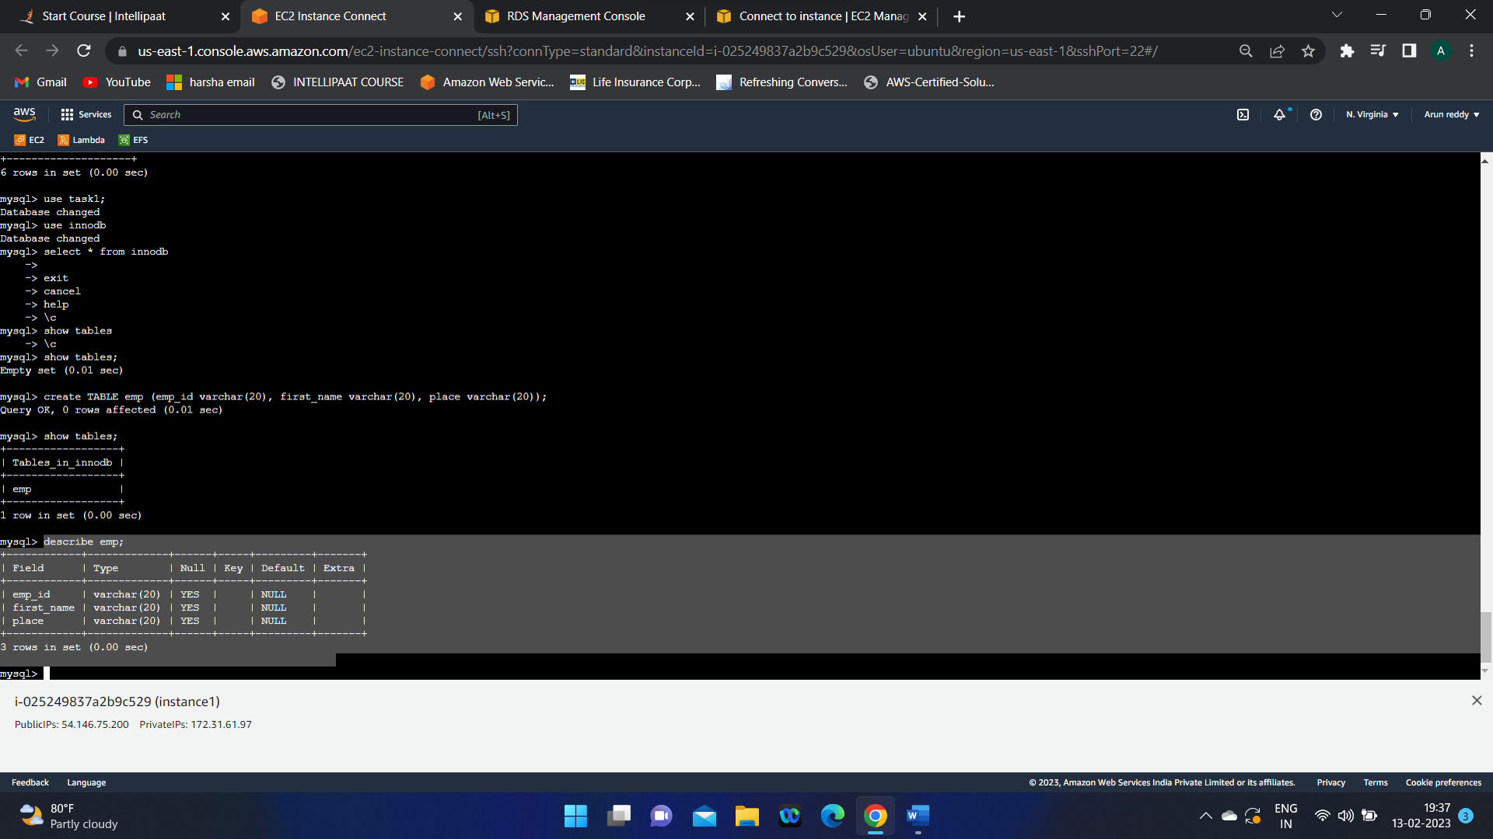

**Assignment -1 completed.**

**Assignment-2 – Create Aurora with two RR**

1.create amazon Aurora DB

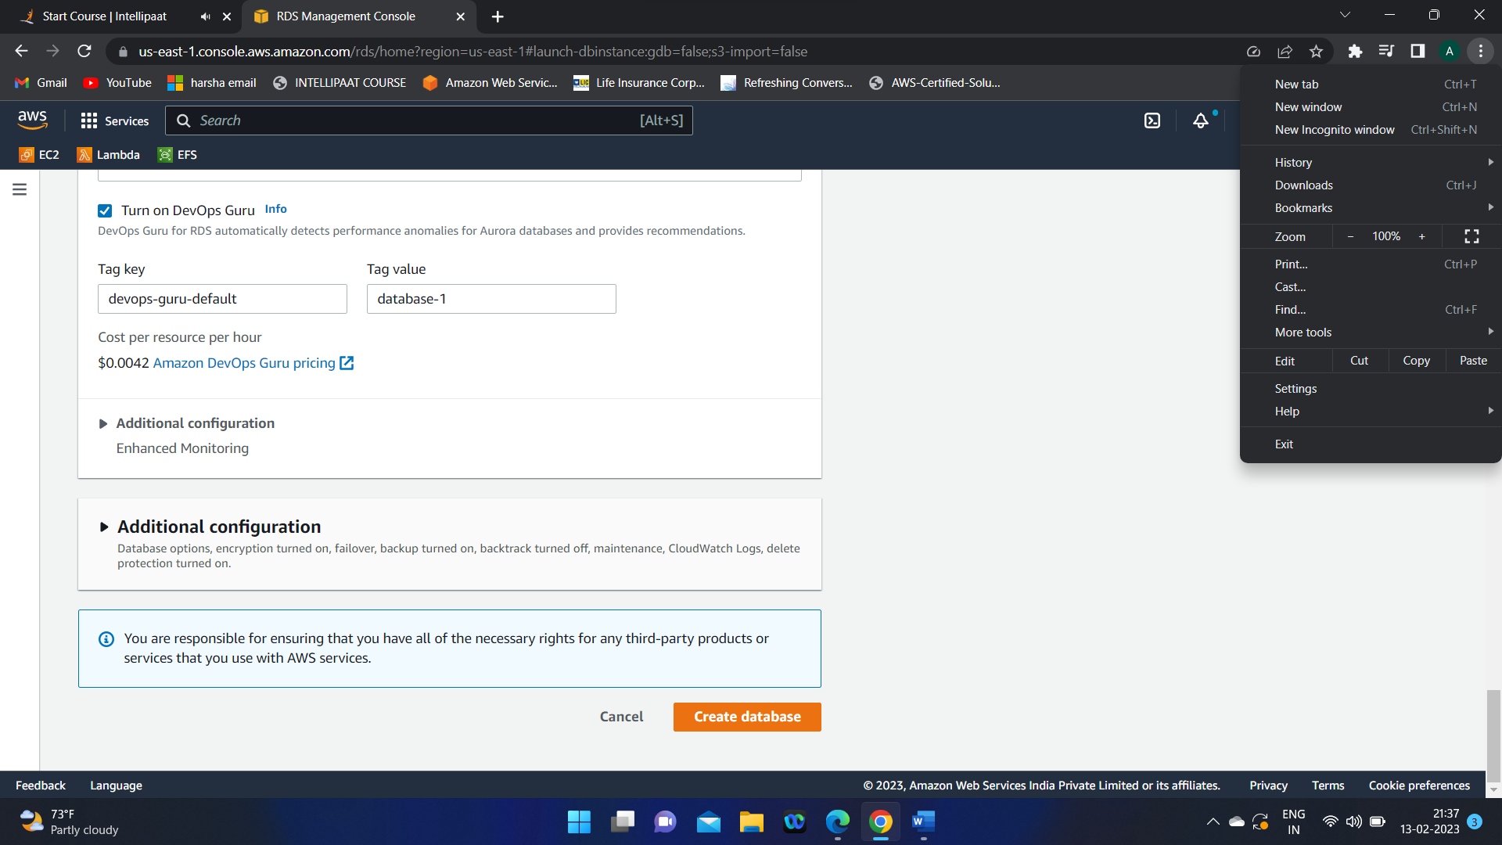

We can see a DB(database-2) with an instance (cluster):

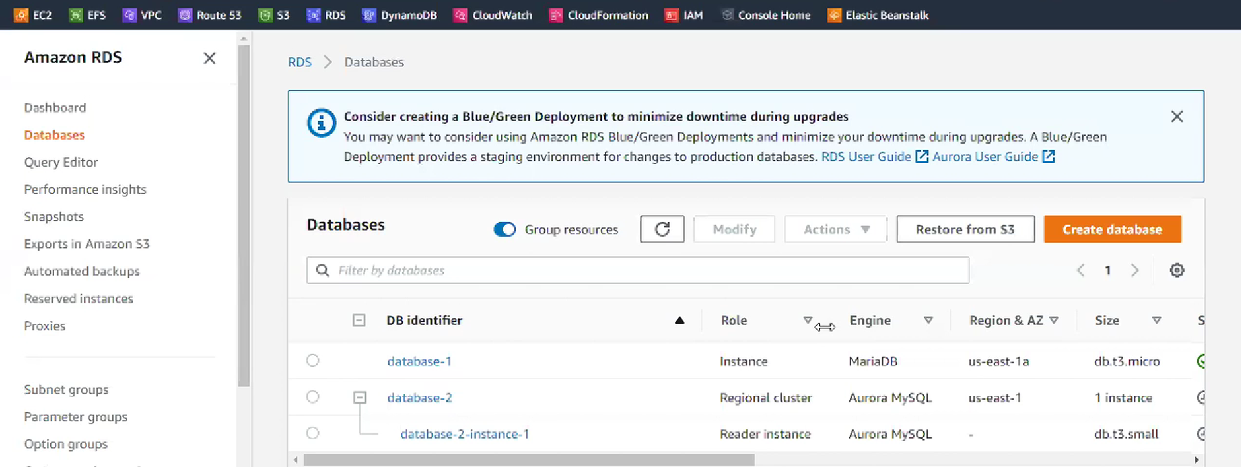

2.Create a Parameter Group

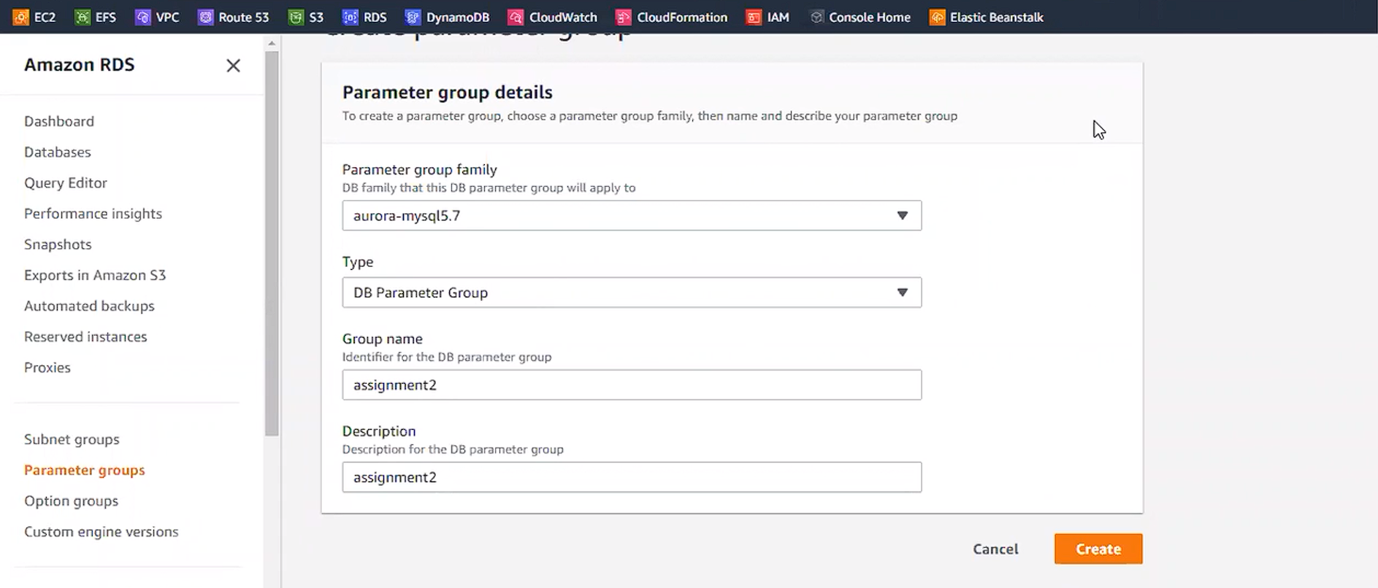

3.Select the parameter group which we created -> Go to Edit parameters.

3.1) Search for binlog (binary logs contains the information of clusters that we are creating)

3.2) In the binlog_format: select MIXED (bilogs are used to create a connection b/w the Database and Instance , so that’s why we are Enabling it in this step)

3.3) Save Changes

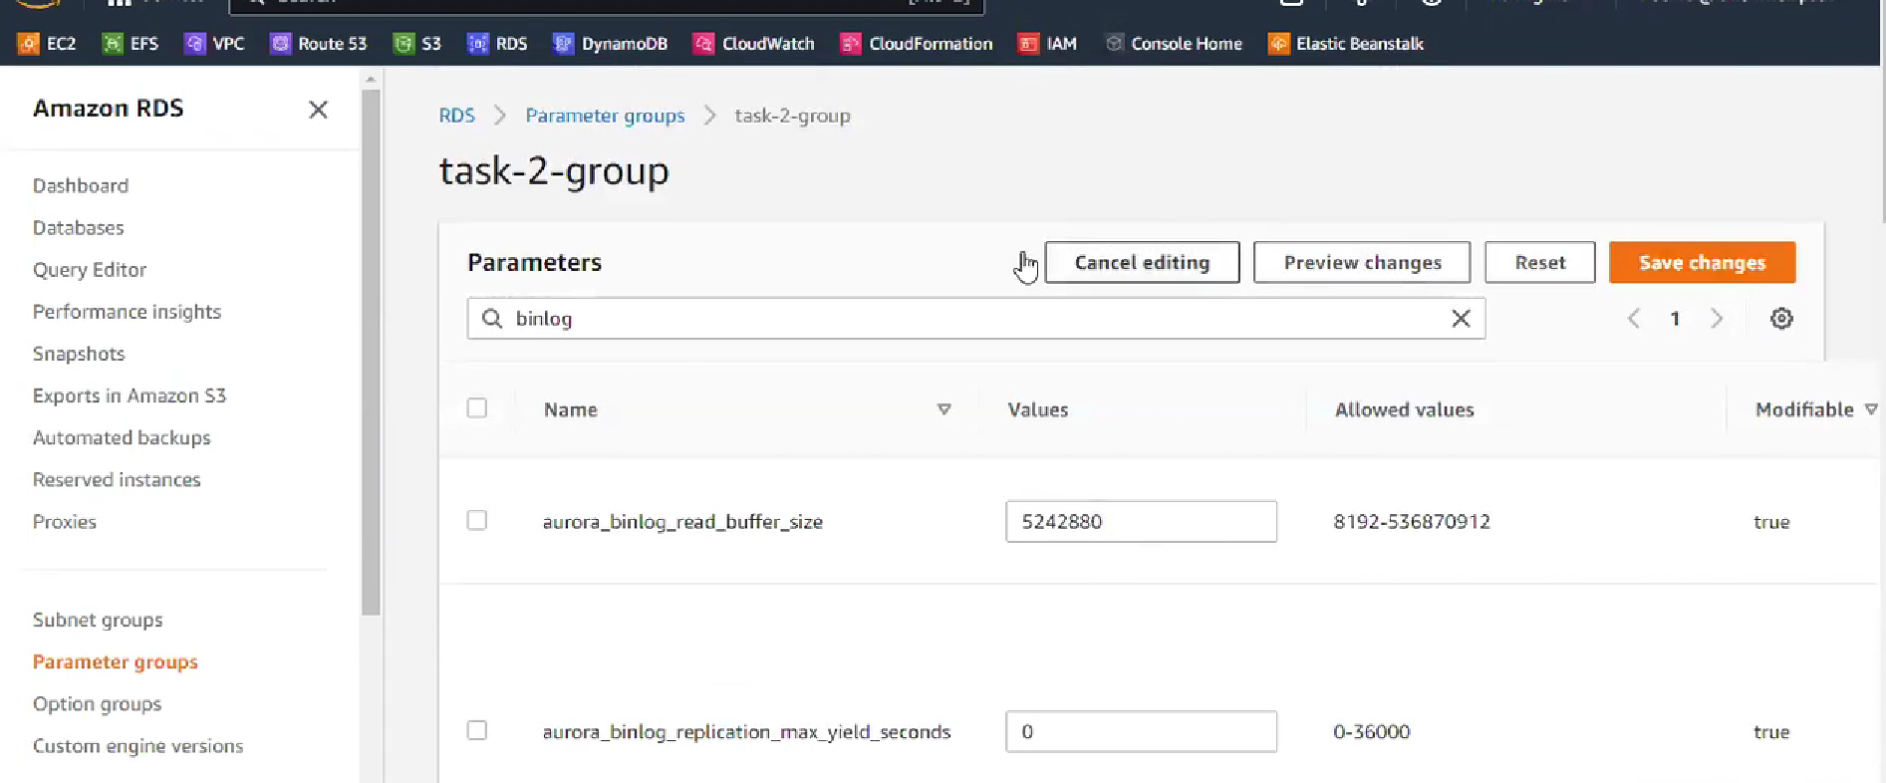

4.Goto Databases, select the Aurora database which we created and Modify

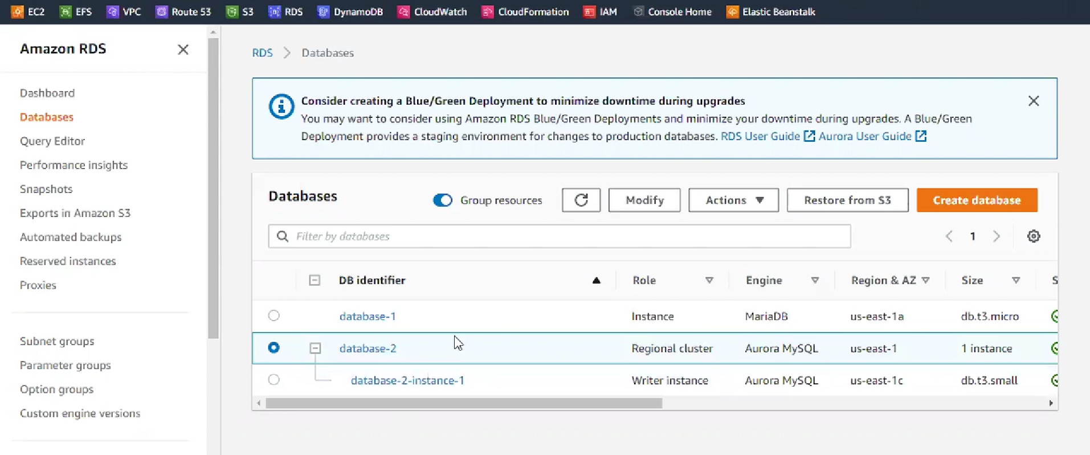

1. In Modify section , under Additional configuration, Select the Parameter Group that we created -> continue and Modify.

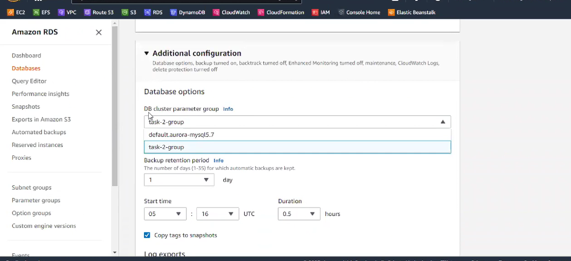

6.Now go back to Database Section again , and select our Database2 and create Cross Region Read Replica

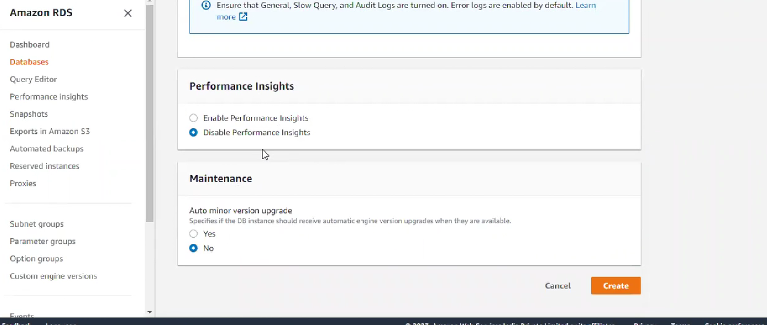

6.1) Ensure that you have selected the SUBNET Group to select TWO AZ’s

7.Go to the region which u have selected for RR’s and check in Databases section, you will find

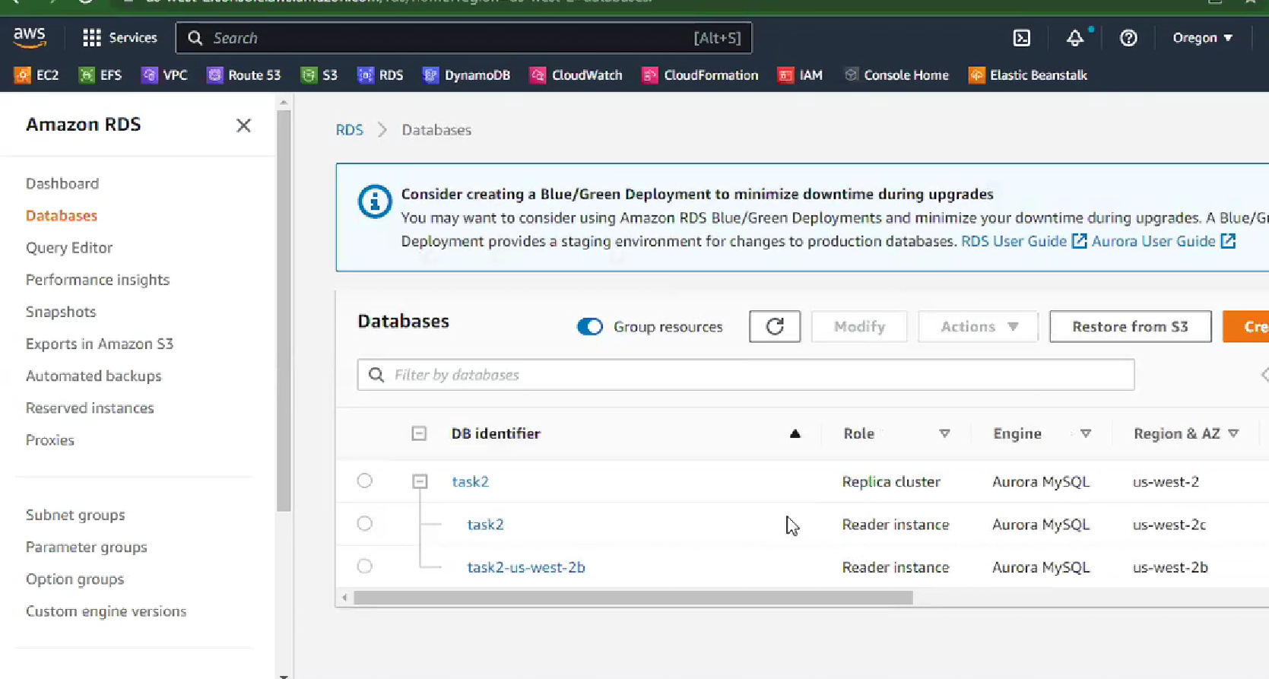

Ignore the task2-us-west-2b instance , it was wrongly created .

**Assignment -2 Completed**

NEED TO COMPLETE ASSG-2(PENDING)

**Assignment -3**

1.Create Table , and add tems into it

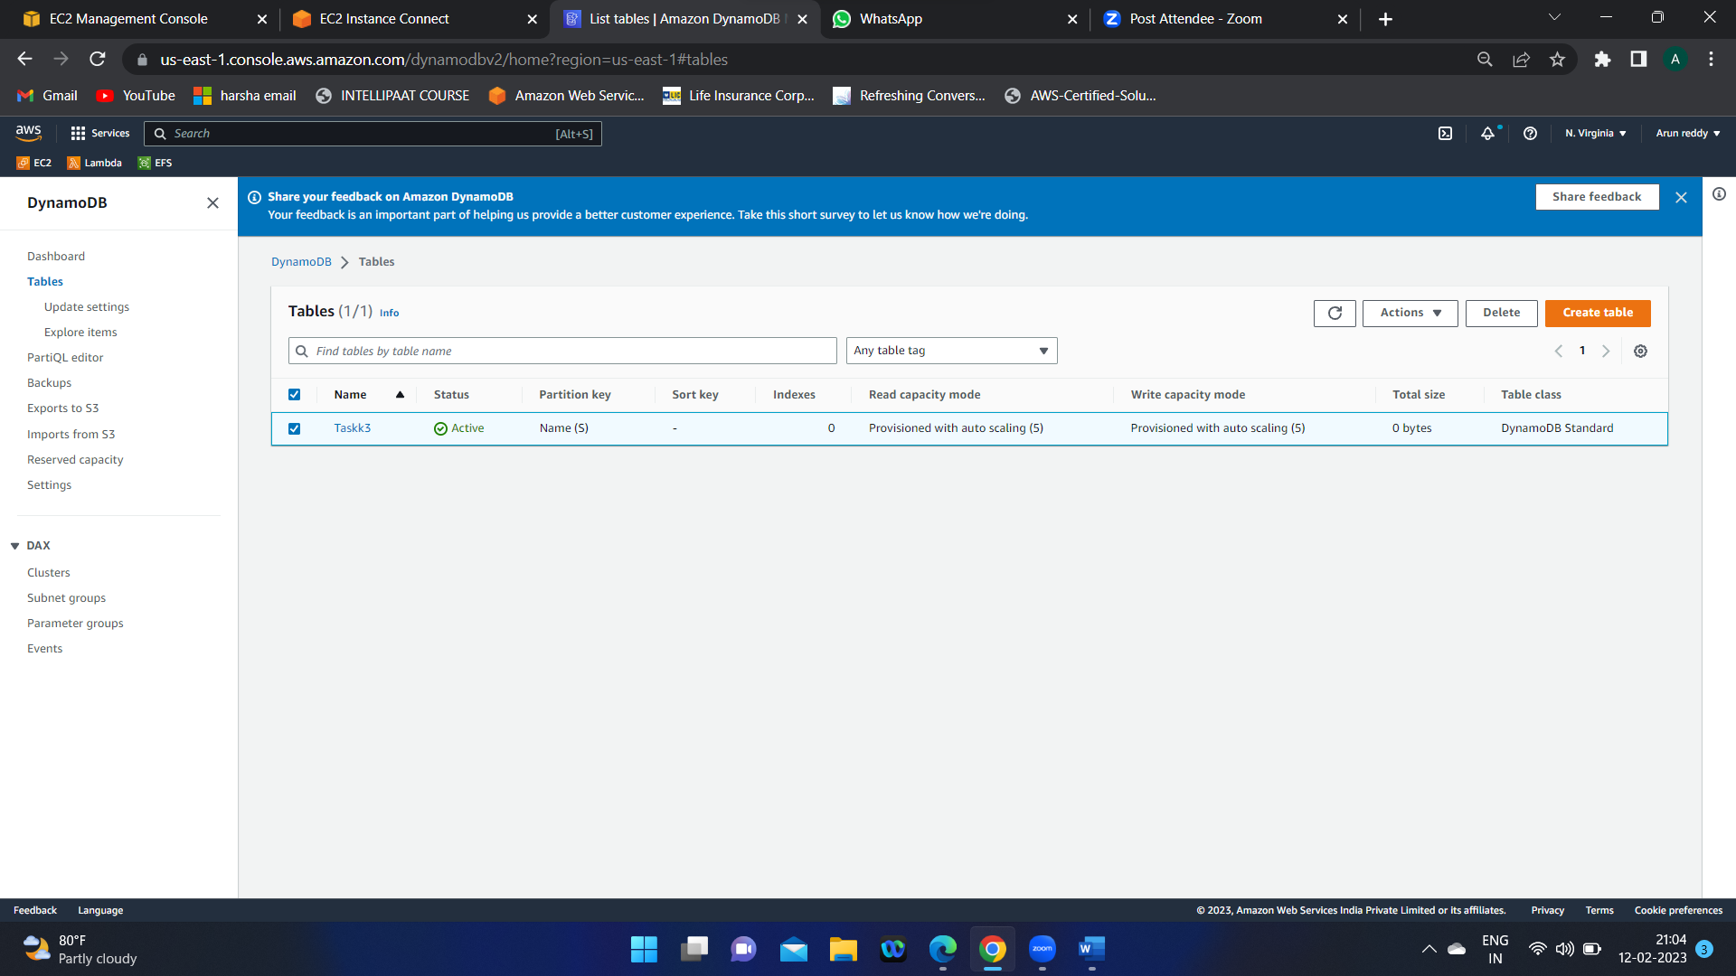

2.add items

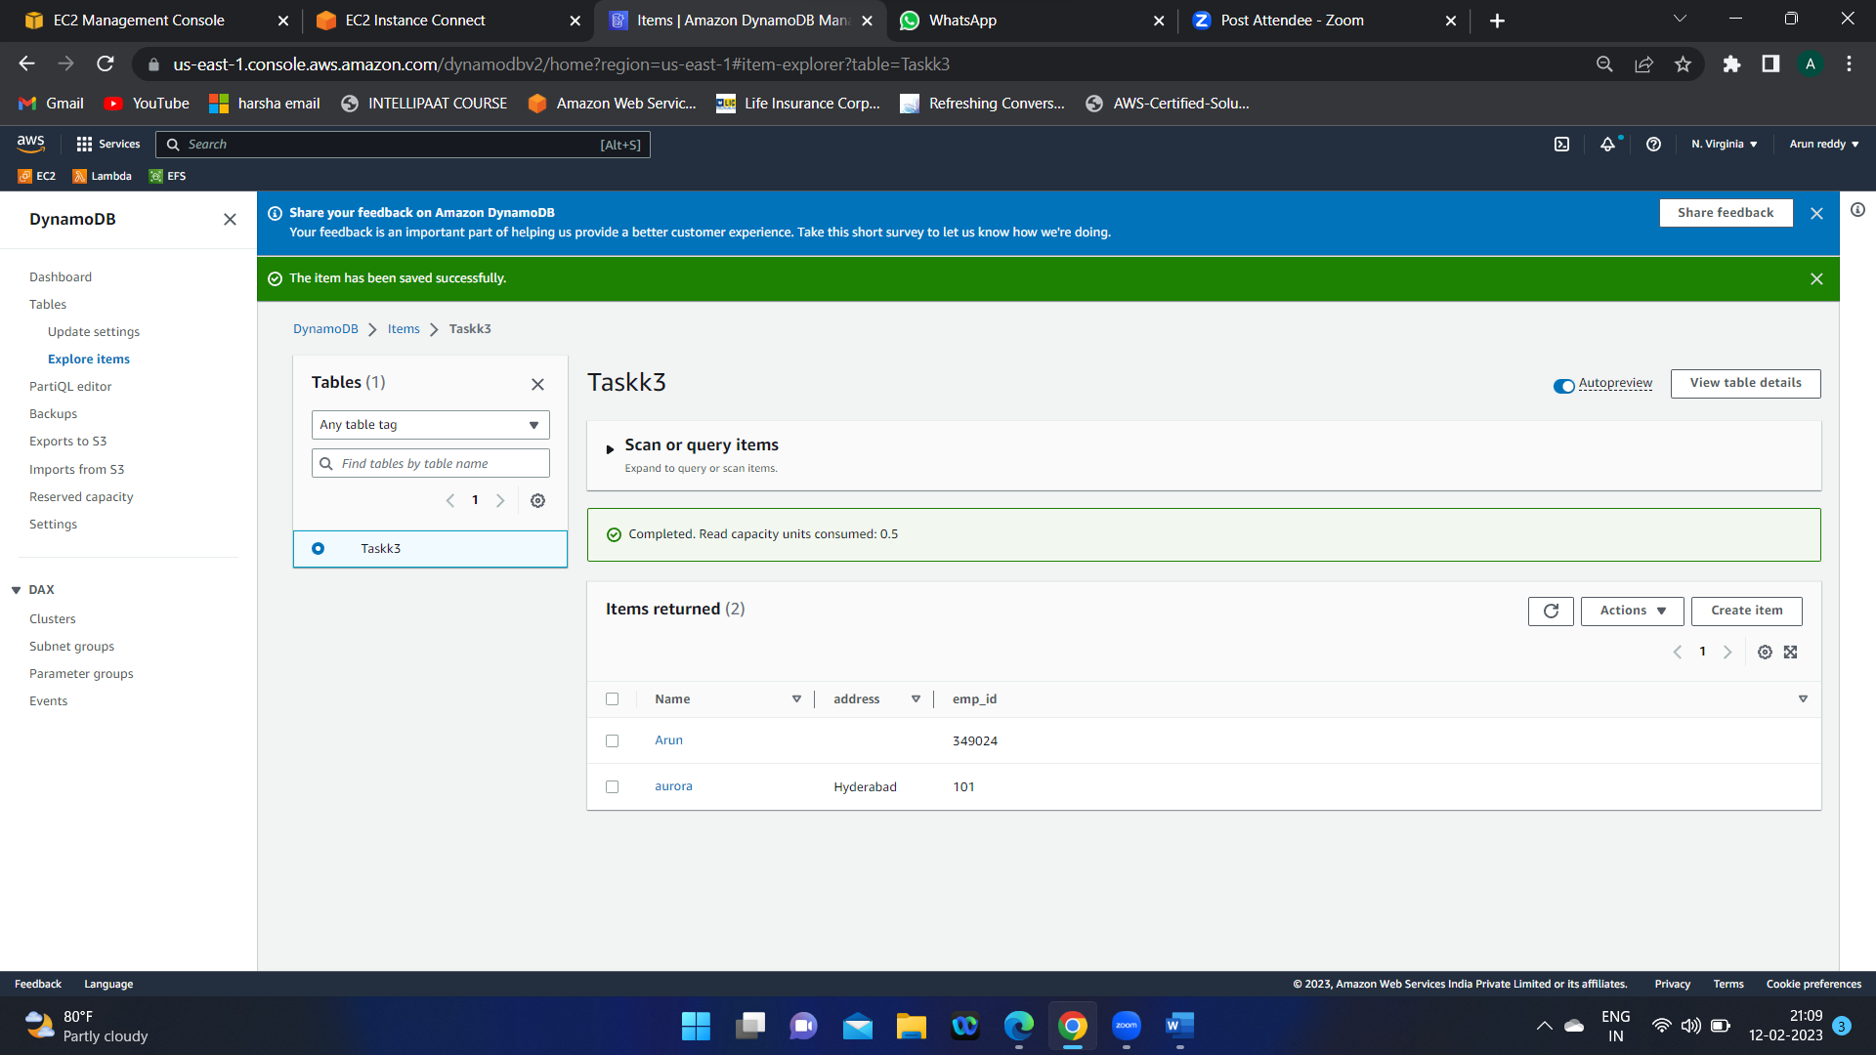

2.Create Backup for this:

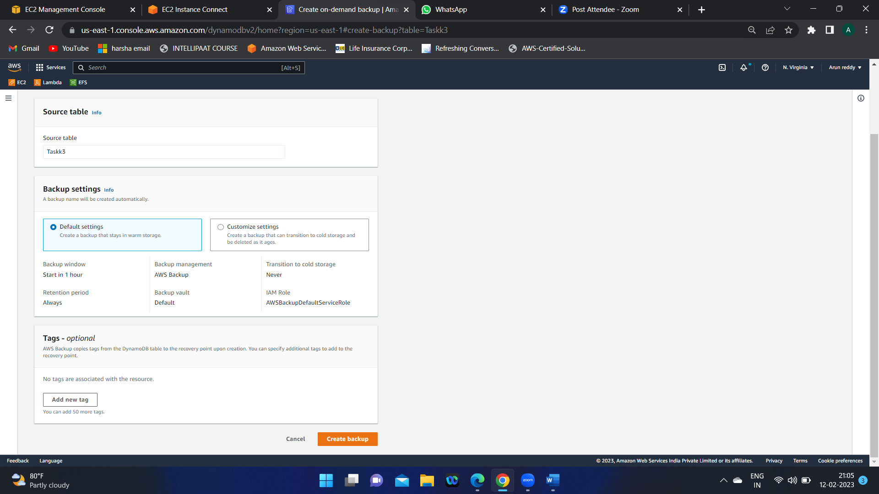

After that Delete the Backup and DDB aswell.

**Assignment 3 completed**

**Assignment -4 Redshift :**

1.Create a cluster in Amazon Redshift

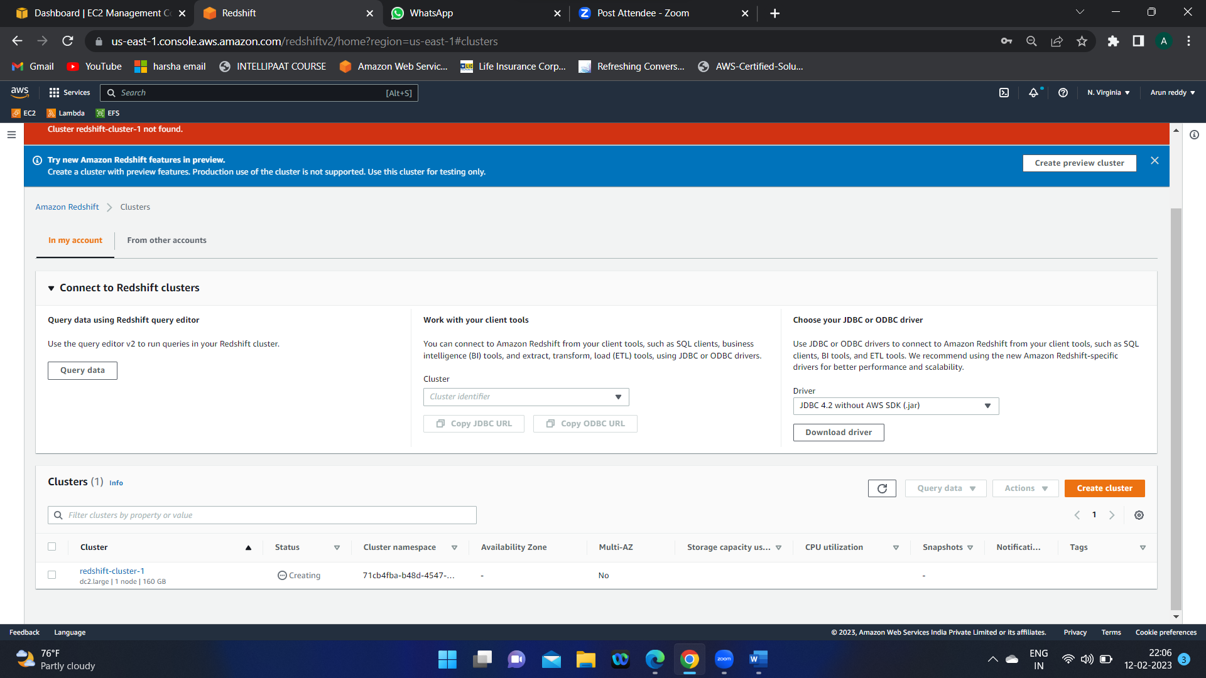

2.choose the Redshift Query editor2

3.Select the data from DEV ->Public ->tables -> Date

